***Directions:*** Complete the Questions below (10 points each). Display a snippet of the code and the output below:

**COP2335: Object-Oriented Programming Lab 8**

1) Complete this program by filling in the code (places in bold). Note: use only pointer variables when instructed to by the comments in bold. This program is to test your knowledge of pointer variables and the & and * symbols.

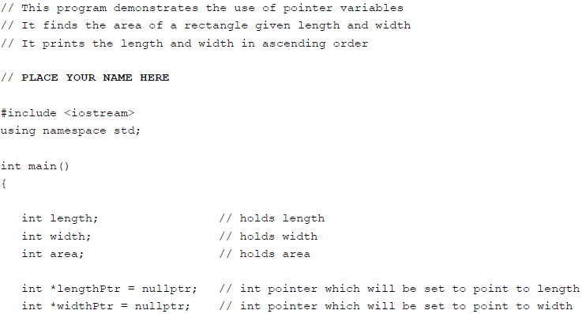

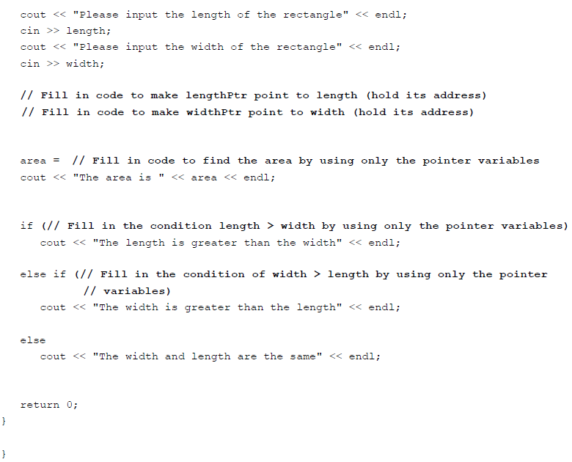

**Snippet of the Output:**

*Exercise 2:* Run the program with the following data: 10 15. Provide a snippet below of the code:

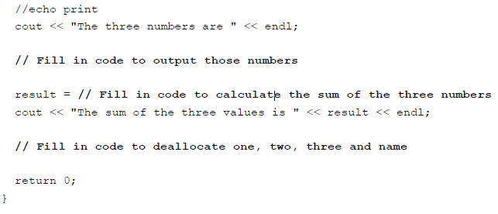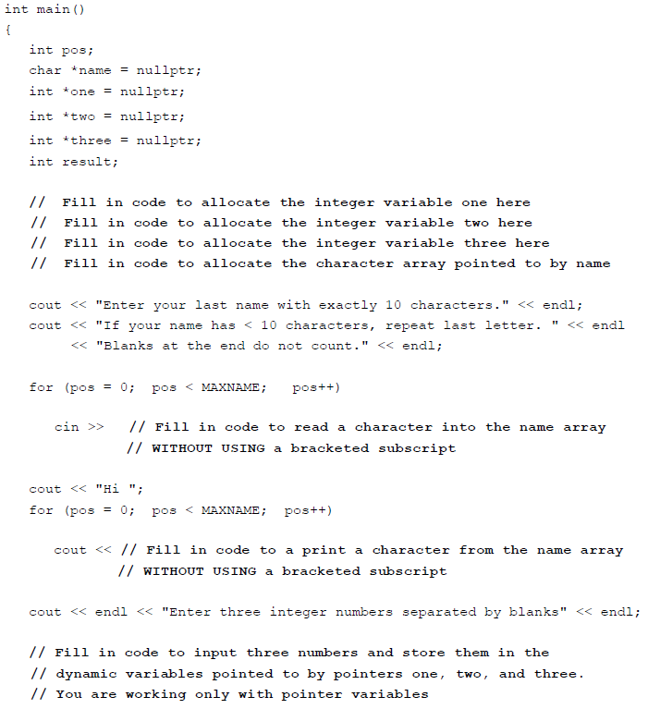2) Complete the program by filling in the code. (Areas in bold) This problem requires that you study very carefully the code already written to prepare you to complete the program.

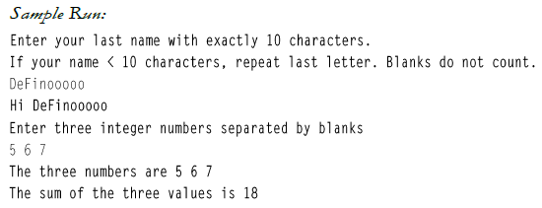

**Snippet of the Code:**

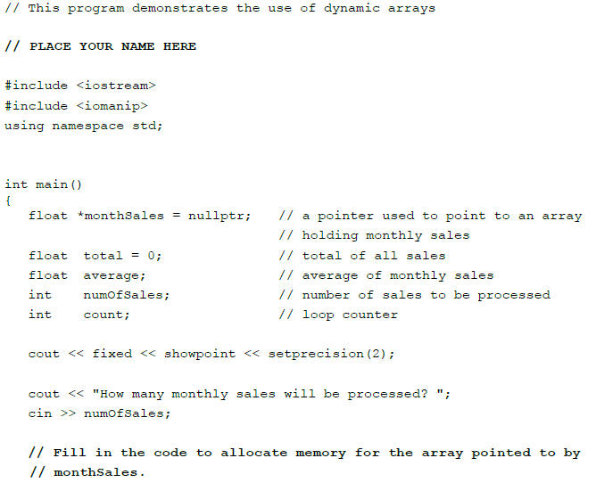3) Fill in the code as indicated by the comments in bold.

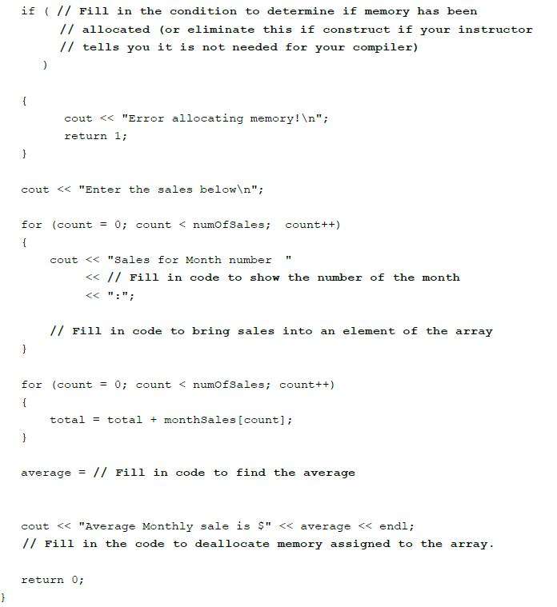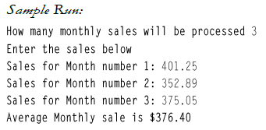

**Snippet of the Output:**

4) Write a program that will read scores into an array. The size of the array should be input by the user (dynamic array). The program will find and print out the average of the scores. It will also call a function that will sort (using a bubble sort) the scores in ascending order. The values are then printed in this sorted order.

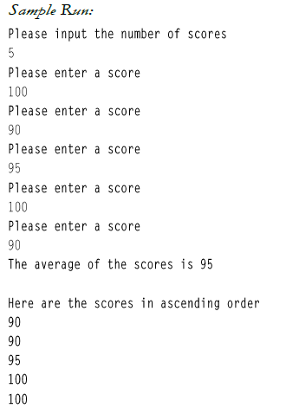

**Snippet of the Code:**

5) Create a program that will read in id numbers and place them in an array. The array is dynamically allocated large enough to hold the number of id numbers given by the user. The program will then input an id and call a function to search for that id in the array. It will print whether the id is in the array or not.

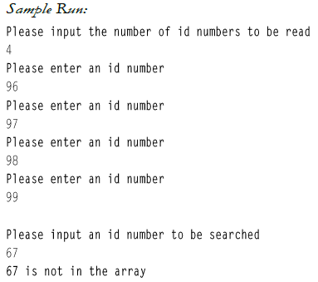

**Snippet of the Output:**

